

**RGB LED Brightness Control V1.0 Design**

Peter Essam | ARM | 26/11/2023

**Table of Content**

1. Introduction
2. High Level Design

* Layered Architecture
* Modules Descriptions
* Drivers Documentations
* GPIO
* GPT(Timer)
* TIMER MANAGER
* LED
* BUTTON

1. Low Level Design

* Flow Chart
* Precompiling Configurations
* Linking Configurations

**Introduction**

* **Overview:**

**This project is designed with a layered architecture, separating concerns into different layers for better maintainability and scalability. The project focuses on controlling an RGB LED using GPIO (General Purpose Input/Output) pins. The Microcontroller Abstraction Layer (MCAL) handles low-level hardware interactions, the Hardware Abstraction Layer (HAL) manages LED and button functionality, the Service Layer manage the drivers in MCAL to can included in application and the Common Layer provides standard library names for consistency.**

* **Layers:**

**MCAL (Microcontroller Abstraction Layer)**

Responsible for low-level hardware interactions.

Utilizes GPIO to control hardware-level features

And GPT to calculate time and generate pwm.

Abstracts microcontroller-specific details.

HAL (Hardware Abstraction Layer)

Manages higher-level functionalities for LEDs and buttons.

Uses MCAL services to control GPIO pins.

Provides an abstraction for RGB LED control and button input.

Service Layer

Manage the drivers in MCAL layer to can included in App layer

Common Layer

Hosts standard library names and common services.

App (Application Layer)

This is the Application

* **Project Functionality:**

The main objective of this project is to control an RGB LED based on button presses and time calculated. The RGB LED is connected to specific GPIO pins on the microcontroller. When a button is pressed, the program detects the button press through the HAL layer, and the RGB LED changes its state accordingly and when the time finish the LED is off .

* Key Components :

MCAL Layer

GPIO driver: Provides low-level functions for GPIO pin initialization, reading, and writing.

HAL Layer

LED Interface: functions to control the RGB LED (e.g., turning on, turning off , ….).

Button Interface: Handles button-related operations (e.g., detecting button presses).

Service Layer

Facilitation control any driver in MCAL want to included in App layer.

Common Layer

Standard Library Names: Ensures consistent naming conventions and library usage across the project.

* **Workflow:**

**Initialization:**

**MCAL initializes GPIO pins for the RGB LED**

**And initialize GPT(Timer) to generate time and pwm.**

**HAL initializes LED and button components.**

**Button Press Detection:**

**HAL layer monitors the button state and detects button presses.**

**RGB LED Control:**

**Based on button presses, the HAL layer controls the RGB LED through the MCAL GPIO driver.**

**Possible actions: turn on, turn off, change color.**

* **Benefits:**

**Modularity**

**Each layer is modular, making it easier to modify or extend functionalities.**

**Abstraction**

**Higher layers abstract hardware details, promoting code readability.**

**Consistency**

**Standard library names in the common layer ensure consistent coding practices.**

* **Conclusion:**

**This project showcases a well-organized architecture with separate layers, each serving a specific purpose. The use of MCAL, HAL, Service Layer and a Common Layer contributes to code clarity, maintainability, and scalability, making it easier to manage and expand the functionality of the RGB LED control system.**

**High Level Design**

* Layered Architecture

**COMMON**

**APP**

**SERVICE (Timer Manager)**

**HAL (led, Button)**

**MCAL (DIO , GPT)**

* Modules Descriptions

MCAL Layer

GPIO driver : Provides low-level functions for GPIO pin initialization, reading, and writing to control RGB Leds signals.

HAL Layer

LED driver: control the RGB LED (e.g., led initialization , led on, led off , led toggle)

Button driver: Handles button-related operations (e.g., button initialization, detecting button presses).\

Service Layer

Control MCAL drivers in App layer

Common Layer

Standard Library Names: to serve all project layers

App Layer

This is the application i want to do

* Drivers Documentations
* GPIO

(This Driver Located in MCAL Layer)

**1-**

**enu_MGPIO_errorStatus_t MGPIO_init(str_MGPIO_configuration_t *ptr_str_MGPIO_config)**

**Description:**

**Initializes a GPIO pin based on the provided configuration.**

**Arguments:**

**ptr_str_MGPIO_config Pointer to a structure contain GPIO config**

**Return:**

**GPIO_OK: Successful initialization.**

**GPIO_NULL_POINTER: Null pointer argument.**

**GPIO_PORT_ERROR: Invalid port number.**

**GPIO_PIN_ERROR: Invalid pin number.**

**GPIO_DIRECTION_ERROR: Invalid pin direction.**

**GPIO_MODE_ERROR: Invalid mode selection.**

**GPIO_OUT_CURRENT_ERROR: Invalid output current.**

**GPIO_INTERNAL_TYPE_ERROR: Invalid internal type.**

**GPIO_VALUE_ERROR: Invalid output level.**

**2-**

**enu_MGPIO_errorStatus_t MGPIO_write(enu_MGPIO_portNumber_t enu_a_portNumber, enu_MGPIO_pinNumber_t enu_a_pinNumber, enu_MGPIO_pinValue_t enu_l_pinValue)**

**Description:**

**Write a value to a specific GPIO pin.**

**Arguments:**

**enu_a_portNumber Select the GPIO port number.**

**enu_a_pinNumber Select the GPIO pin number.**

**enu_l_pinValue Select the value to be written to the pin (PIN_HIGH_VALUE or PIN_LOW_VALUE).**

**Return:**

**GPIO_OK Success operation.**

**GPIO_PORT_ERROR Invalid port number.**

**GPIO_PIN_ERROR Invalid pin number.**

**GPIO_VALUE_ERROR Invalid pin value.**

**GPIO_PORT_NOT_INITIALIZED Port not initialized.**

**3-**

**enu_MGPIO_errorStatus_t MGPIO_read(enu_MGPIO_portNumber_t enu_a_portNumber, enu_MGPIO_pinNumber_t enu_a_pinNumber, boolean *ptr_arg_pinValue)**

**Description:**

**Read the value of a specific GPIO pin.**

**Arguments:**

**enu_a_portNumber Select the GPIO port number.**

**enu_a_pinNumber Select the GPIO pin number.**

**ptr_arg_pinValue Pointer to a boolean variable to store the read value.**

**Return**

**GPIO_OK Success operation.**

**GPIO_PORT_ERROR Invalid port number.**

**GPIO_PIN_ERROR Invalid pin number.**

**GPIO_NULL_POINTER Null pointer argument.**

**GPIO_PORT_NOT_INITIALIZED Port not initialized.**

**4-**

**enu_MGPIO_errorStatus_t MGPIO_read(enu_MGPIO_portNumber_t enu_a_portNumber, enu_MGPIO_pinNumber_t enu_a_pinNumber, boolean *ptr_arg_pinValue)**

**Description:**

**Toggle the value of a specific GPIO pin.**

**Arguments:**

**enu_a_portNumber Select the GPIO port number.**

**enu_a_pinNumber Select the GPIO pin number.**

**Return**

**GPIO_OK Success operation.**

**GPIO_PORT_ERROR Invalid port number.**

**GPIO_PIN_ERROR Invalid pin number.**

**GPIO_PORT_NOT_INITIALIZED Port not initialized**

* GPT (Timer)

(This Driver Located in MCAL Layer)

**1-**

**enu_MTIMER_status_t M_timerInit(str_MTIMER_configurations_t *ptr_timerConfigurations)**

**Description:**

**Initializes the specified timer based on the provided configurations.**

**Arguments:**

**ptr_timerConfigurations Pointer to a structure containing timer configurations.**

**Return:**

**enu_MTIMER_status_t Error status after timer initialization.**

**2-**

**enu_MTIMER_status_t M_timerStart(enu_MTIMER_timerSelect_t enu_arg_timerSelect , uint32_t u32_arg_desiredTime , enu_timeUnit_t enu_arg_timeUnit)**

**Description:**

**Starts the specified timer with the desired time and time unit**

**Arguments:**

**enu_arg_timerSelect The selected timer to start.**

**u32_arg_desiredTime The desired time to run the timer.**

**enu_arg_timeUnit The time unit of the desired time (microseconds, milliseconds, seconds).**

**Return:**

**enu_MTIMER_status_t Error status after starting the timer.**

**3-**

**enu_MTIMER_status_t M_timerEnableInterrupt(enu_MTIMER_timerSelect_t enu_arg_timerSelect)**

**Description:**

**Enables interrupts for the specified timer.**

**Arguments:**

**enu_arg_timerSelect The selected timer to enable interrupts**

**Return:**

**enu_MTIMER_status_t Error status after enabling interrupts.**

**4-**

**enu_MTIMER_status_t M_timerDisableInterrupt(enu_MTIMER_timerSelect_t enu_arg_timerSelect)**

**Description:**

**Disable interrupts for the specified timer.**

**Arguments:**

**enu_arg_timerSelect The selected timer to disable interrupts**

**Return:**

**enu_MTIMER_status_t Error status after disabling interrupts.**

**5-**

**enu_MTIMER_status_t M_Timer_getElapsedTime(enu_MTIMER_timerSelect_t enu_arg_timerSelect , uint32_t *u32_ptr_timeMs)**

**Description:**

**Retrieves the elapsed time from the specified timer.**

**Arguments:**

**enu_arg_timerSelect The selected timer to retrieve elapsed time.**

**u32_ptr_timeMs Pointer to store the elapsed time in milliseconds.**

**Return:**

**enu_MTIMER_status_t Error status after retrieving elapsed time.**

**6-**

**enu_MTIMER_status_t M_TIMER_getRemainingTime (enu_MTIMER_timerSelect_t enu_arg_timerSelect , uint32_t *u32_ptr_timeMs)**

**Description:**

**Retrieves the remaining time from the specified timer.**

**Arguments:**

**enu_arg_timerSelect The selected timer to retrieve remaining time.**

**u32_ptr_timeMs Pointer to store the remaining time in milliseconds.**

**Return:**

**enu_MTIMER_status_t Error status after retrieving remaining time.**

**7-**

**enu_MTIMER_status_t M_stopTimer(enu_MTIMER_timerSelect_t enu_arg_timerSelect)**

**Description:**

**Stop the specified timer.**

**Arguments:**

**enu_arg_timerSelect The selected timer stop time.**

**Return:**

**enu_MTIMER_status_t Error status stop time.**

**8-**

**enu_MTIMER_status_t M_TIMER_set_pwm(enu_MTIMER_timerSelect_t enu_arg_timerSelect , uint16_t u16_arg_durationMs , uint8_t u8_arg_dutyCycle)**

**Description:**

**Configure timer for set PWM operation.**

**Arguments:**

**enu_arg_timerSelect The selected timer to configure for PWM.**

**u16_arg_durationMs The total duration of the PWM signal in milliseconds.**

**u8_arg_dutyCycle The duty cycle of the PWM signal as a percentage.**

**Return:**

**enu_MTIMER_status_t Error status after configuring the timer for PWM.**

* LED

(This Driver Located in HAL Layer)

**1-**

**enu_ledErrorState_t H_LED_init(enu_MGPIO_portNumber_t enu_l_ledPort, enu_MGPIO_pinNumber_t enu_l_ledPin)**

**Description:**

**Initialize a LED on a specific GPIO port and pin**

**Arguments:**

**enu_l_ledPort Select the GPIO port number for the LED.**

**enu_l_ledPin Select the GPIO pin number for the LED.**

**Return**

**LED_OK Success initialization.**

**LED_NOT_OK LED initialization not successful.**

**2-**

**enu_ledErrorState_t H_LED_on(enu_MGPIO_portNumber_t enu_l_ledPort, enu_MGPIO_pinNumber_t enu_l_ledPin)**

**Description:**

**Turn on a LED connected to a specific GPIO port and pin.**

**Arguments:**

**enu_l_ledPort Select the GPIO port number for the LED.**

**enu_l_ledPin Select the GPIO pin number for the LED.**

**Return**

**LED_OK Success initialization.**

**LED_NOT_OK LED initialization not successful.**

**3-**

**enu_ledErrorState_t H_LED_off(enu_MGPIO_portNumber_t enu_l_ledPort, enu_MGPIO_pinNumber_t enu_l_ledPin)**

**Description:**

**Turn off a LED connected to a specific GPIO port and pin.**

**Arguments:**

**enu_l_ledPort Select the GPIO port number for the LED.**

**enu_l_ledPin Select the GPIO pin number for the LED.**

**Return**

**LED_OK Success initialization.**

**LED_NOT_OK LED initialization not successful.**

**4-**

**enu_ledErrorState_t H_LED_toggle(enu_MGPIO_portNumber_t enu_l_ledPort, enu_MGPIO_pinNumber_t enu_l_ledPin)**

**Description:**

**Toggle the state of an LED connected to a specific GPIO port and pin.**

**Arguments:**

**enu_l_ledPort Select the GPIO port number for the LED.**

**enu_l_ledPin Select the GPIO pin number for the LED.**

**Return**

**LED_OK Success initialization.**

**LED_NOT_OK LED initialization not successful.**

* BUTTON

(This Driver Located in HAL Layer)

1-

**enu_buttonErrorStatus_t H_BUTTON_init(void)**

**Description:**

**Initialize the configuration of all buttons.**

**Return:**

**BUTTON_OK Success initializing all buttons.**

**BUTTON_NOT_OK Failed to initialize buttons.**

**2-**

**enu_buttonErrorStatus_t H_BUTTON_read(enu_buttonNumber_t enu_a_button_Number, boolean *ptr_a_value)**

**Description:**

**Read the state of a specific button.**

**Arguments:**

**enu_a_button_Number The button number to read.**

**ptr_a_value Pointer to a boolean variable to store the button state.**

**Return:**

**BUTTON_OK Success initializing all buttons.**

**BUTTON_NOT_OK Failed to initialize buttons.**

* TIMER_MANAGER

(This Driver Located in Service Layer)

**1-**

**enu_timerHandlerErrorStatus_t timerHandlerInit(str_MTIMER_configurations_t *str_TIMER_configs)**

**Description:**

**Initializes a timer handler based on the provided timer configurations..**

**Arguments:**

**str_TIMER_configs Pointer to a structure containing timer configurations.**

**Return**

**enu_timerHandlerErrorStatus_t Error status after initializing the timer handler.**

**2-**

**enu_timerHandlerErrorStatus_t timerHandlerStartTimer(enu_MTIMER_timerSelect_t enu_arg_timerSelect ,uint32_t u32_arg_time , enu_timeUnit_t enu_arg_timeUnit)**

**Description:**

**Start a timer handler based on the provided timer configurations..**

**Arguments:**

**enu_arg_timerSelect The selected timer to start.**

**u32_arg_time The duration of the timer.**

**enu_arg_timeUnit The time unit for the duration (e.g., microseconds, milliseconds).**

**Return**

**enu_timerHandlerErrorStatus_t Error status after start the timer handler.**

**3-**

**enu_timerHandlerErrorStatus_t timerHandlerEnableInterrupt(enu_MTIMER_timerSelect_t enu_arg_timerSelect)**

**Description:**

**Enable a timer interrupt handler based on the provided timer configurations..**

**Arguments:**

**enu_arg_timerSelect The selected timer to start.**

**Return**

**enu_timerHandlerErrorStatus_t Error status after disable the timer handler.**

**4-**

**enu_timerHandlerErrorStatus_t timerHandlerDisableInterrupt(enu_MTIMER_timerSelect_t enu_arg_timerSelect)**

**Description:**

**Disable a timer interrupt handler based on the provided timer configurations..**

**Arguments:**

**enu_arg_timerSelect The selected timer to start.**

**Return**

**enu_timerHandlerErrorStatus_t Error status after disable the timer handler.**

**5-**

**enu_timerHandlerErrorStatus_t timerHandlergetElapsedTime (enu_MTIMER_timerSelect_t enu_arg_timerSelect , uint32_t *u32_ptr_time)**

**Description:**

**Retrieves the elapsed time from the specified timer in the timer handler**

**Arguments:**

**Retrieves the elapsed time from the specified timer in the timer handler**

**Return**

**enu_timerHandlerErrorStatus_t Error status after retrieving the elapsed time from the timer handler.**

**6-**

**enu_timerHandlerErrorStatus_t timerHandlerRemainingTime (enu_MTIMER_timerSelect_t enu_arg_timerSelect , uint32_t *u32_ptr_time)**

**Description:**

**Retrieves the remaining time from the specified timer in the timer handler**

**Arguments:**

**Retrieves the remaining time from the specified timer in the timer handler**

**Return**

**enu_timerHandlerErrorStatus_t Error status after retrieving the remaining time from the timer handler.**

**7-**

**enu_timerHandlerErrorStatus_t timerHandlerStopTimer(enu_MTIMER_timerSelect_t enu_arg_timerSelect)**

**Description:**

**Stop timer in timer handler**

**Arguments:**

**enu_arg_timerSelect The selected timer to stop.**

**Return**

**enu_timerHandlerErrorStatus_t Error status after stop the time from the timer handler.**

**8-**

**enu_timerHandlerErrorStatus_t timerHandlerSetPwm(enu_MTIMER_timerSelect_t enu_arg_timerSelect , uint16_t u16_arg_durationMs ,uint8_t u8_arg_dutyCycle)**

**Description:**

**Sets the PWM configuration for the specified timer in the timer handler**

**Arguments:**

**enu_arg_timerSelect The selected timer to set PWM configuration.**

**u16_arg_durationMs The duration of the PWM signal in milliseconds.**

**u8_arg_dutyCycle The duty cycle of the PWM signal as a percentage**

**Return**

**enu_timerHandlerErrorStatus_t Error status after setting PWM configuration in the timer handler.**

**Low Level Design**

* Flow Chart
* GPIO

enu_MGPIO_errorStatus_t MGPIO_write(enu_MGPIO_portNumber_t enu_a_portNumber, enu_MGPIO_pinNumber_t enu_a_pinNumber, enu_MGPIO_pinValue_t enu_l_pinValue)

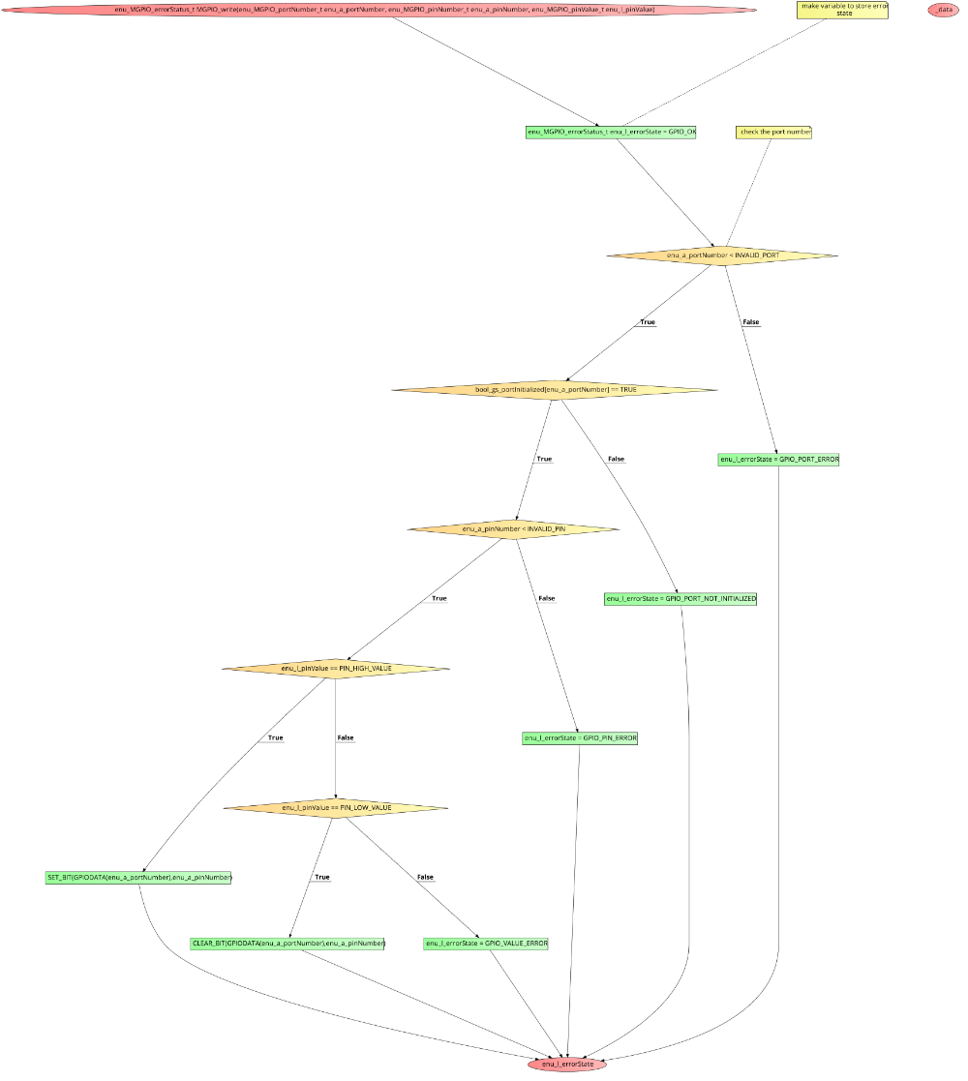

enu_MGPIO_errorStatus_t MGPIO_read(enu_MGPIO_portNumber_t enu_a_portNumber, enu_MGPIO_pinNumber_t enu_a_pinNumber, boolean *ptr_arg_pinValue)

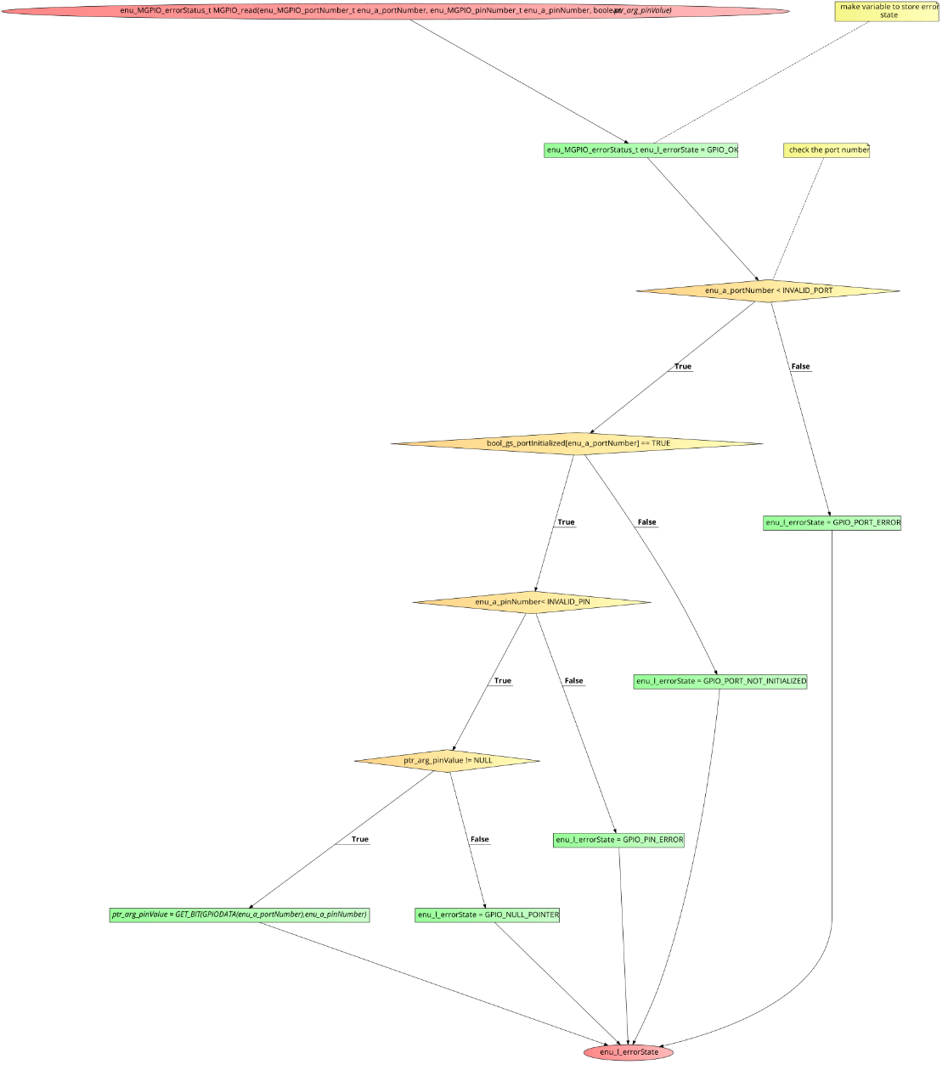

enu_MGPIO_errorStatus_t MGPIO_toggle(enu_MGPIO_portNumber_t enu_a_portNumber , enu_MGPIO_pinNumber_t enu_a_pinNumber)

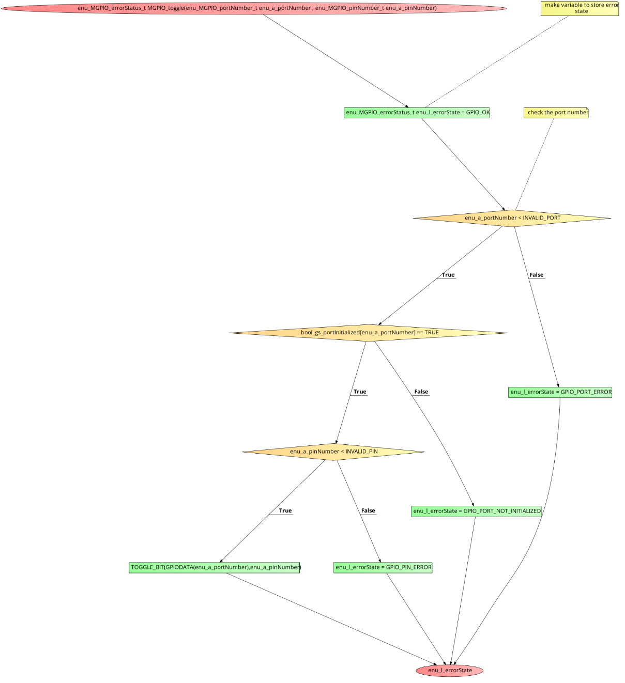

* GPT(Timer)

enu_MTIMER_status_t M_timerStart(enu_MTIMER_timerSelect_t enu_arg_timerSelect , uint32_t u32_arg_desiredTime , enu_timeUnit_t enu_arg_timeUnit)

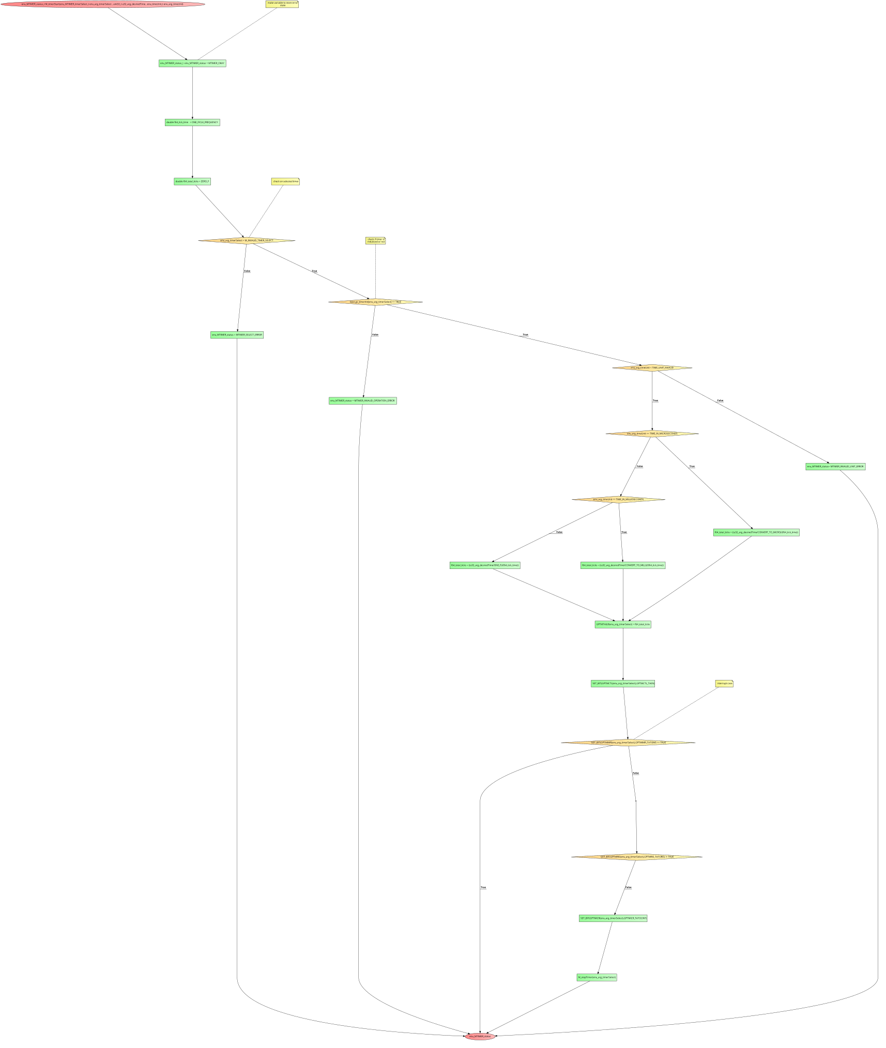

enu_MTIMER_status_t M_timerEnableInterrupt(enu_MTIMER_timerSelect_t enu_arg_timerSelec

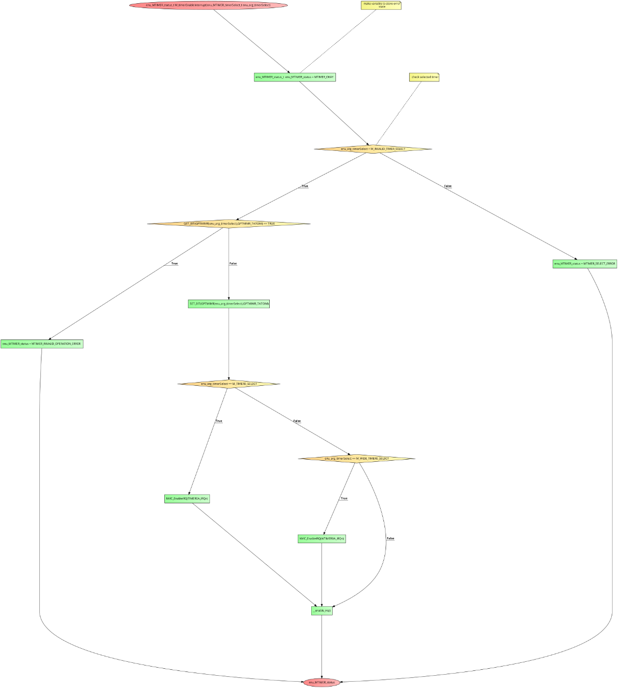

enu_MTIMER_status_t M_timerDisableInterrupt(enu_MTIMER_timerSelect_t enu_arg_timerSelect)

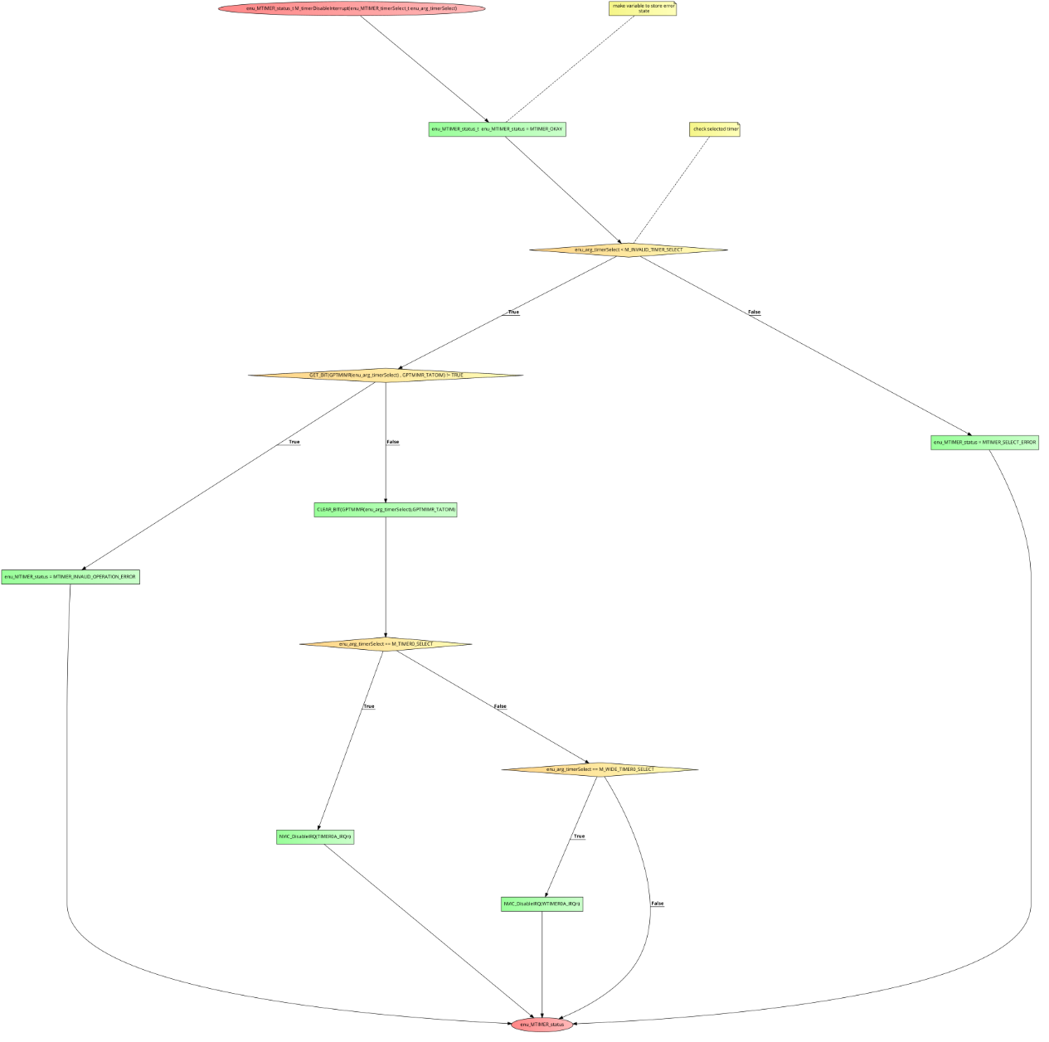

enu_MTIMER_status_t M_Timer_getElapsedTime(enu_MTIMER_timerSelect_t enu_arg_timerSelect , uint32_t *u32_ptr_timeMs)

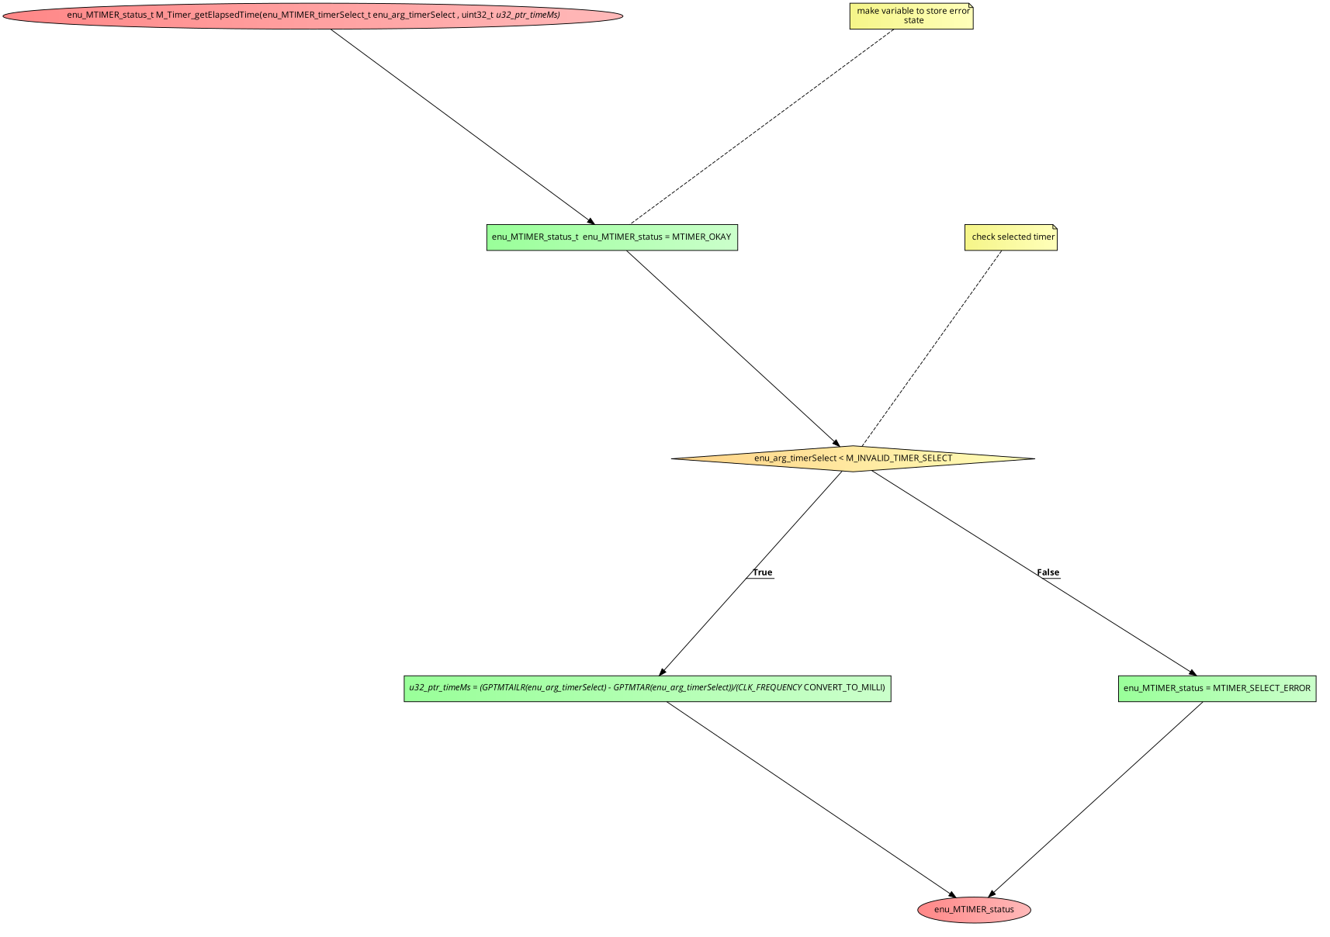

enu_MTIMER_status_t M_TIMER_getRemainingTime (enu_MTIMER_timerSelect_t enu_arg_timerSelect , uint32_t *u32_ptr_timeMs)

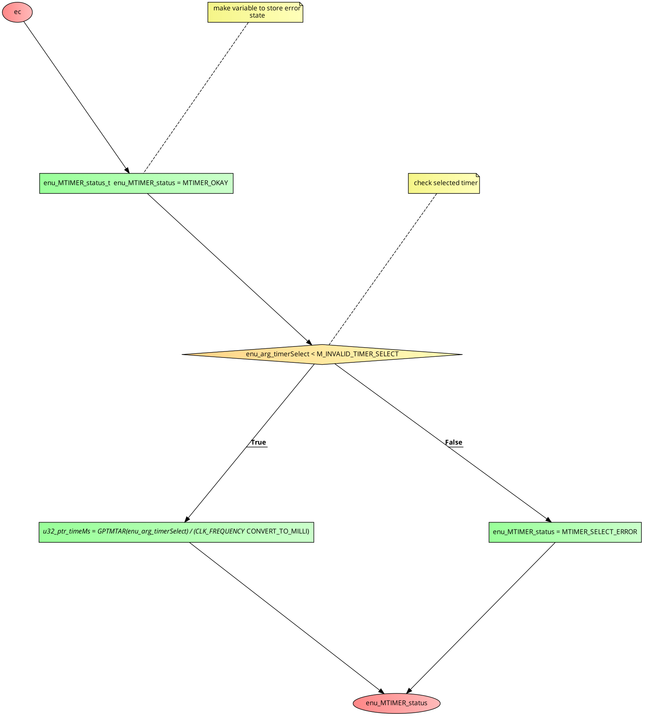

enu_MTIMER_status_t M_stopTimer(enu_MTIMER_timerSelect_t enu_arg_timerSelect)

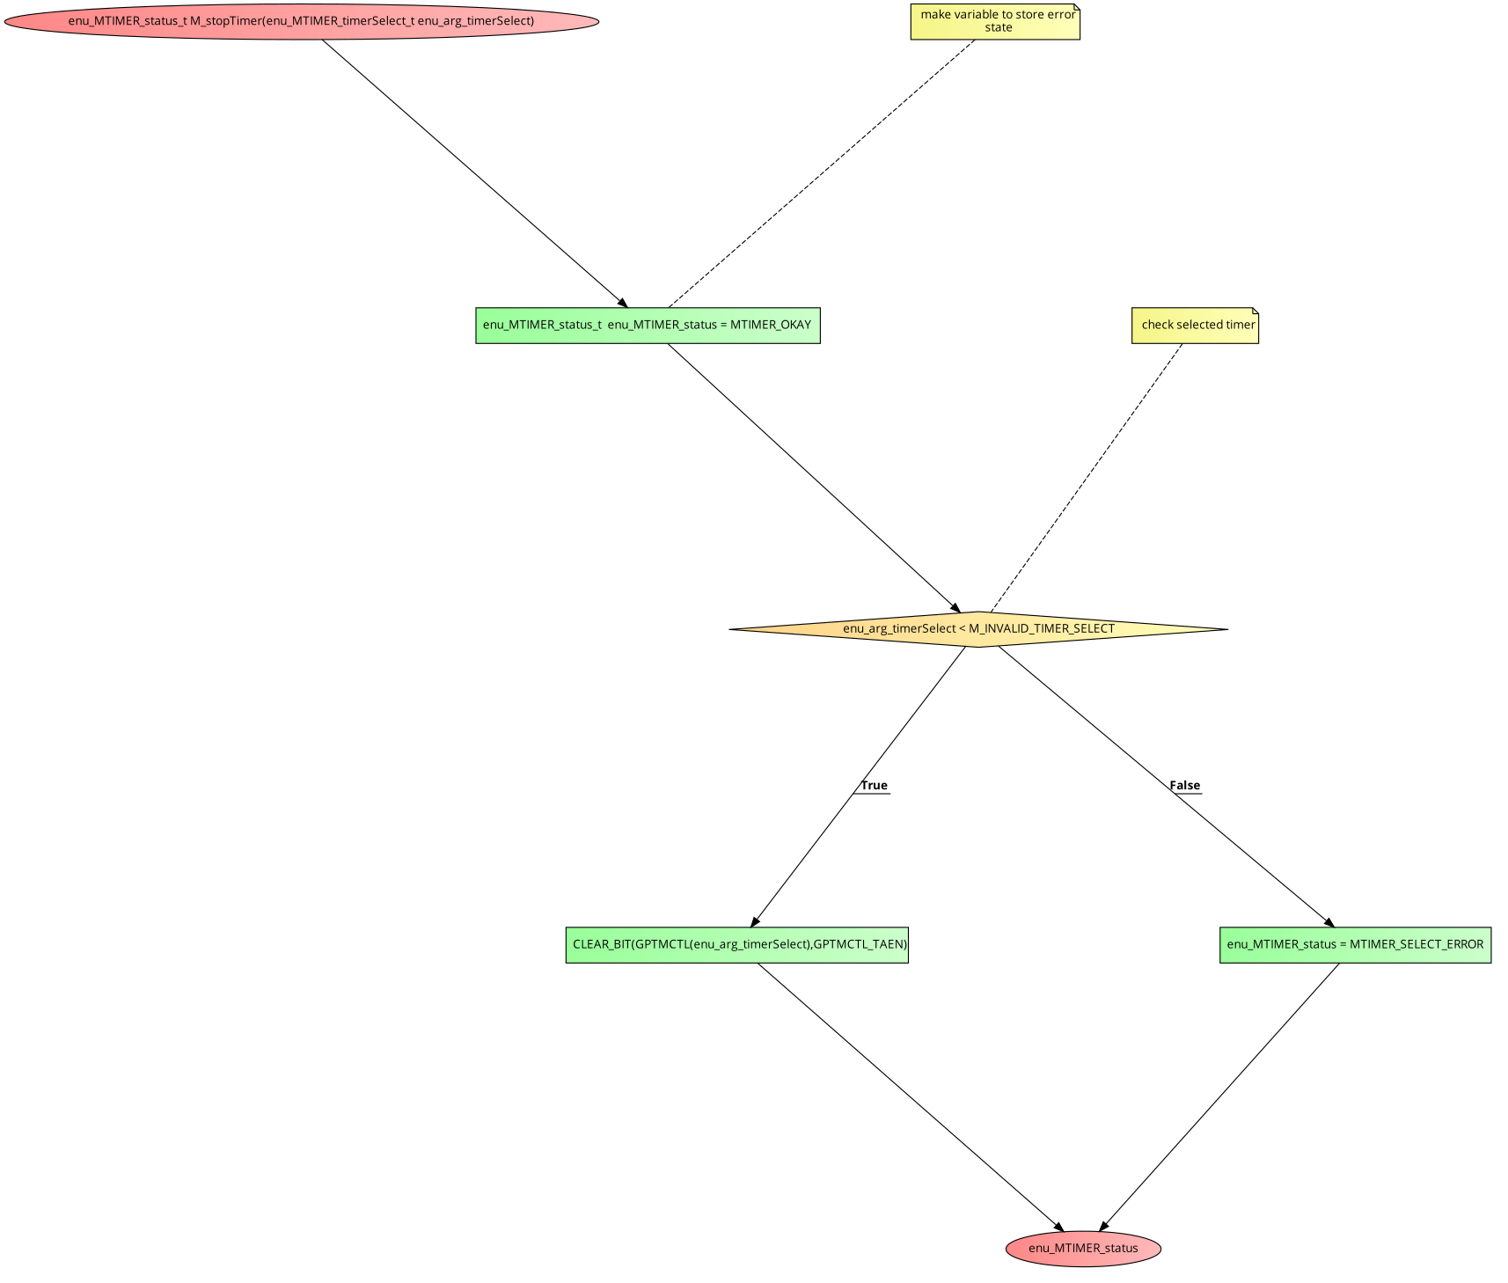

enu_MTIMER_status_t M_TIMER_set_pwm(enu_MTIMER_timerSelect_t enu_arg_timerSelect , uint16_t u16_arg_durationMs , uint8_t u8_arg_dutyCycle)

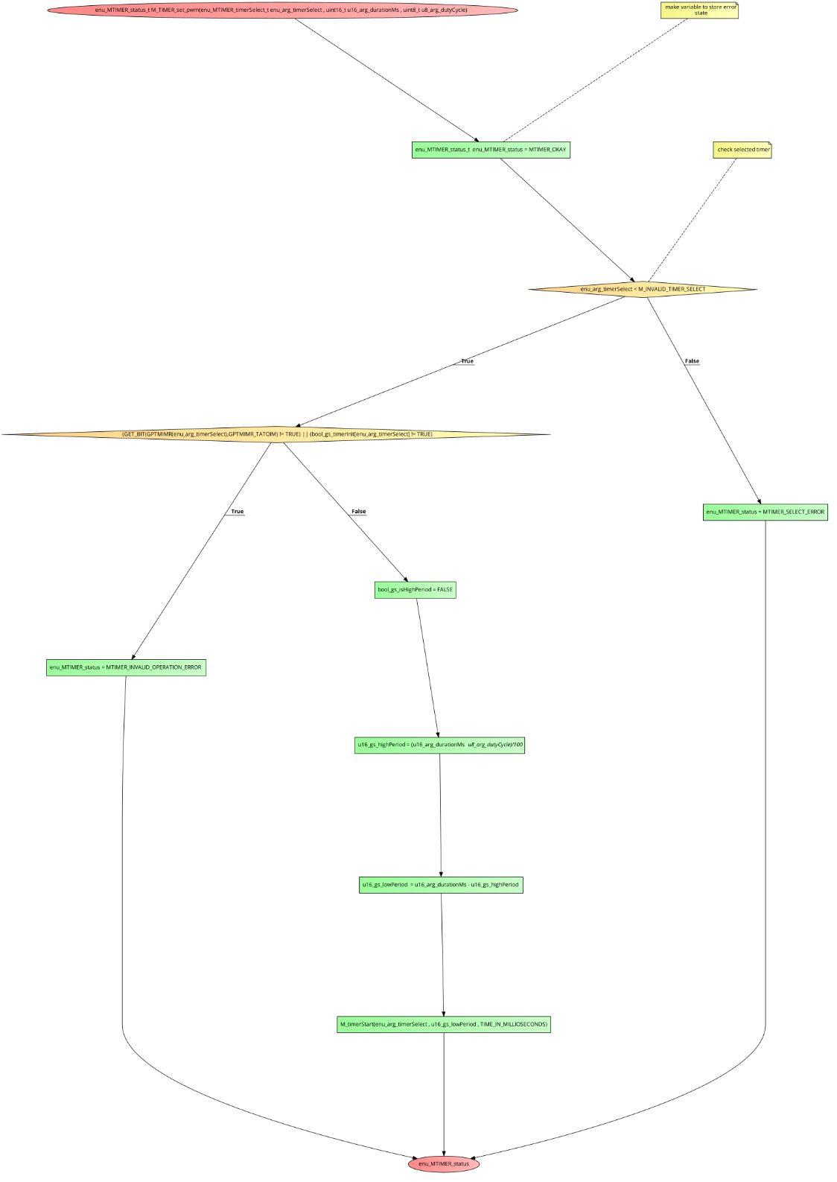

* LED

enu_ledErrorState_t H_LED_init(enu_MGPIO_portNumber_t enu_l_ledPort , enu_MGPIO_pinNumber_t enu_l_ledPin)

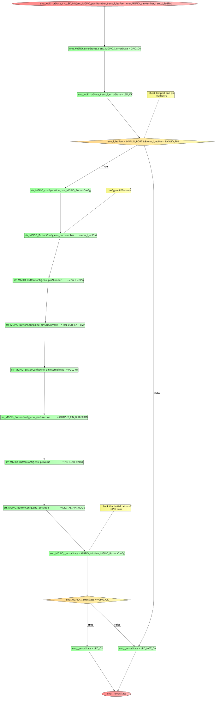

enu_ledErrorState_t H_LED_on(enu_MGPIO_portNumber_t enu_l_ledPort , enu_MGPIO_pinNumber_t enu_l_ledPin)

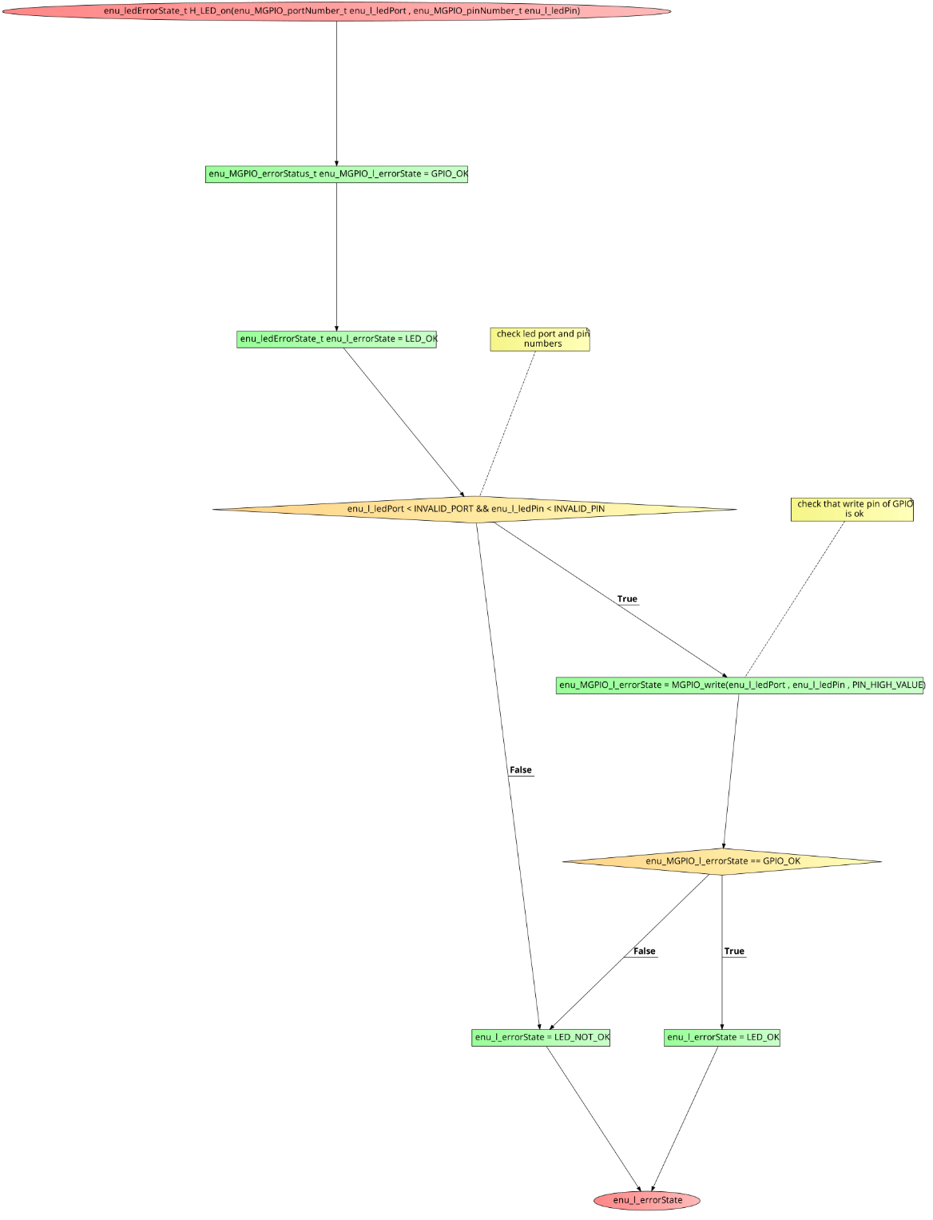

enu_ledErrorState_t H_LED_off(enu_MGPIO_portNumber_t enu_l_ledPort , enu_MGPIO_pinNumber_t enu_l_ledPin)

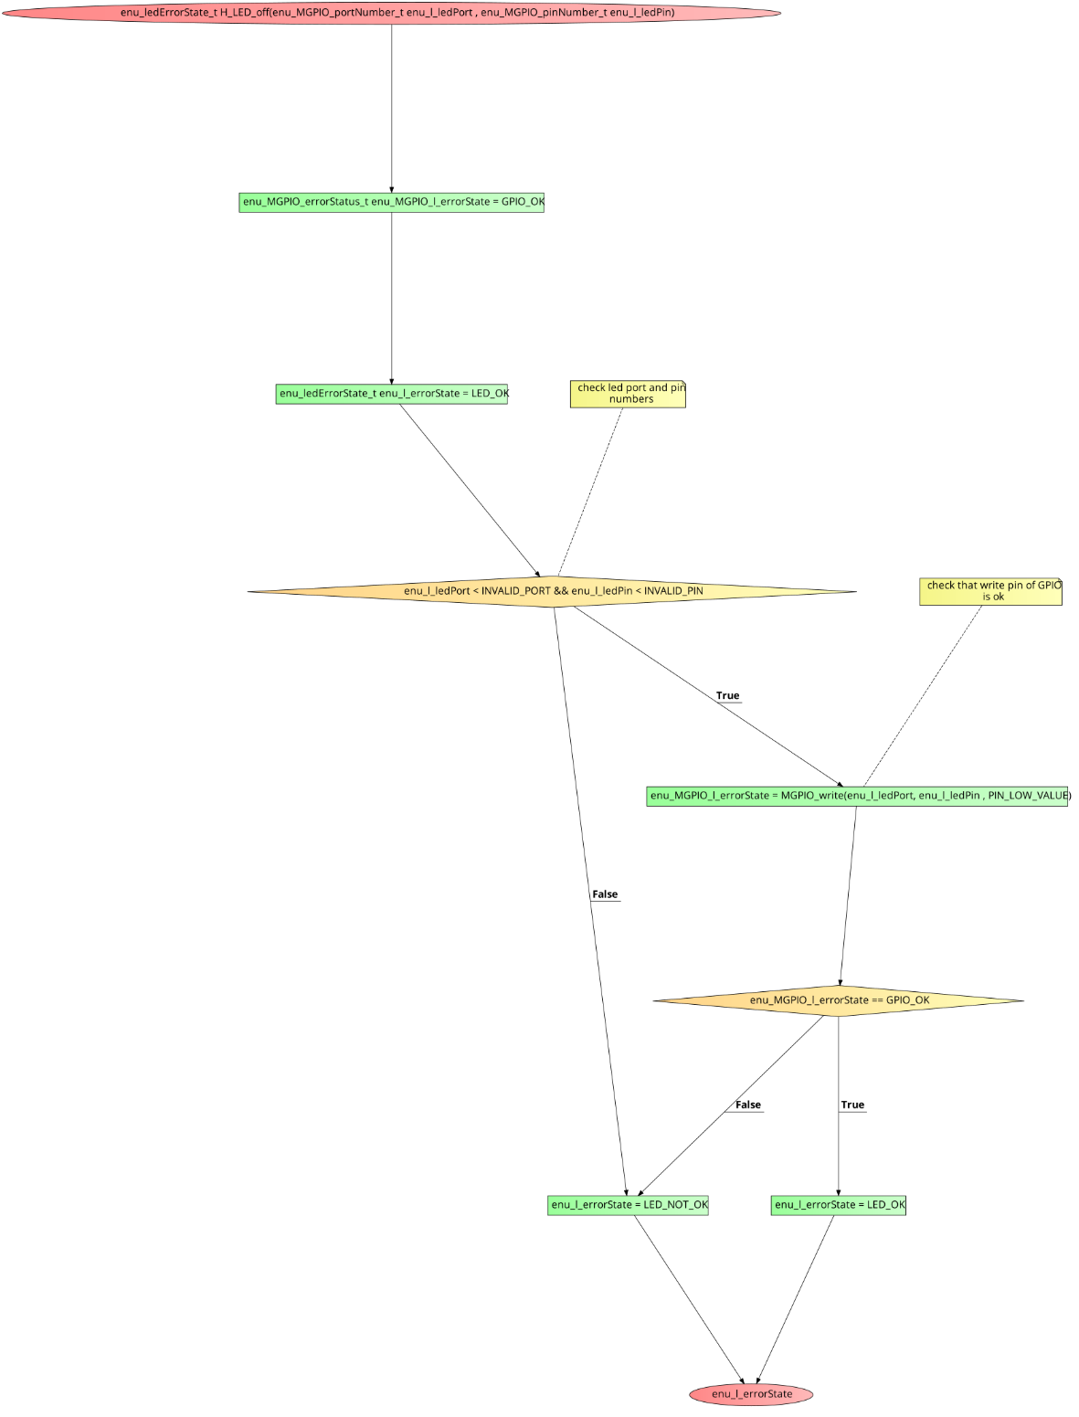

enu_ledErrorState_t H_LED_toggle(enu_MGPIO_portNumber_t enu_l_ledPort , enu_MGPIO_pinNumber_t enu_l_ledPin)

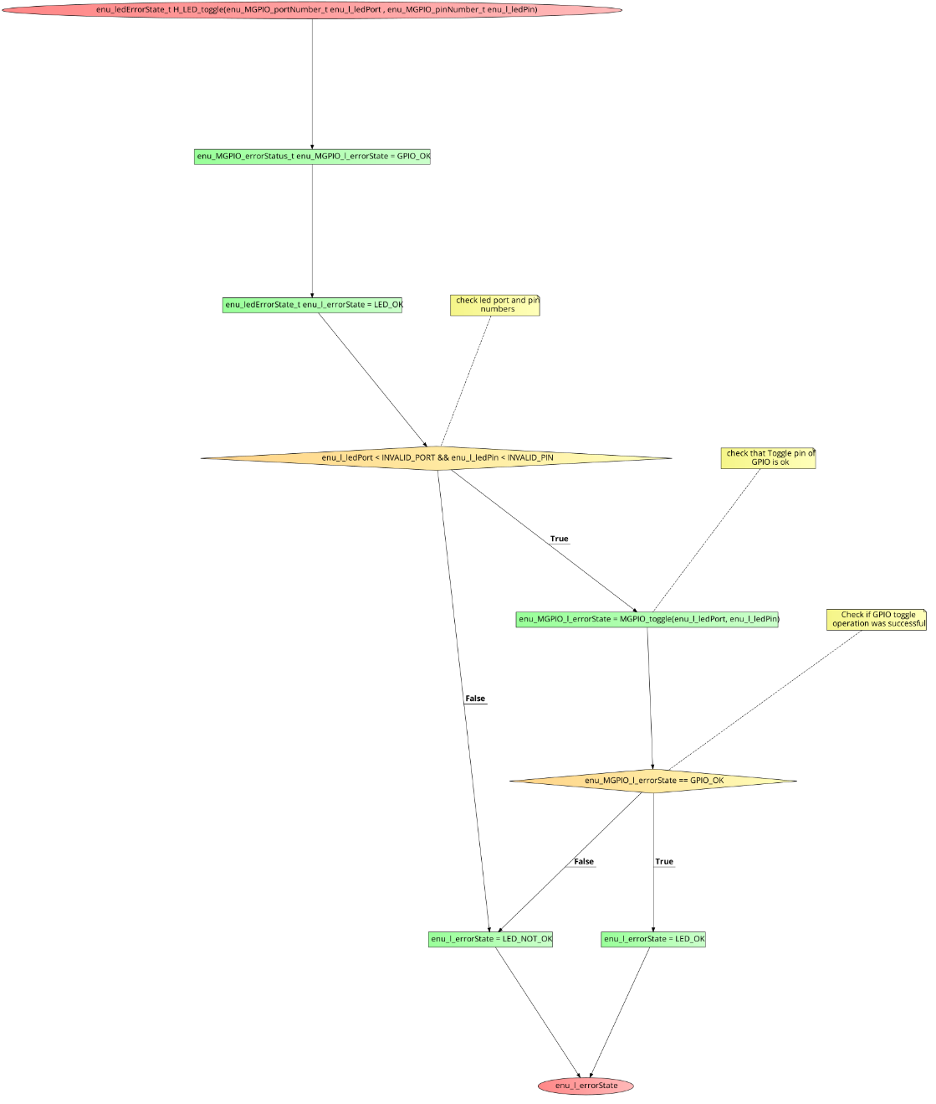

* BUTTON

enu_buttonErrorStatus_t H_BUTTON_init(void)

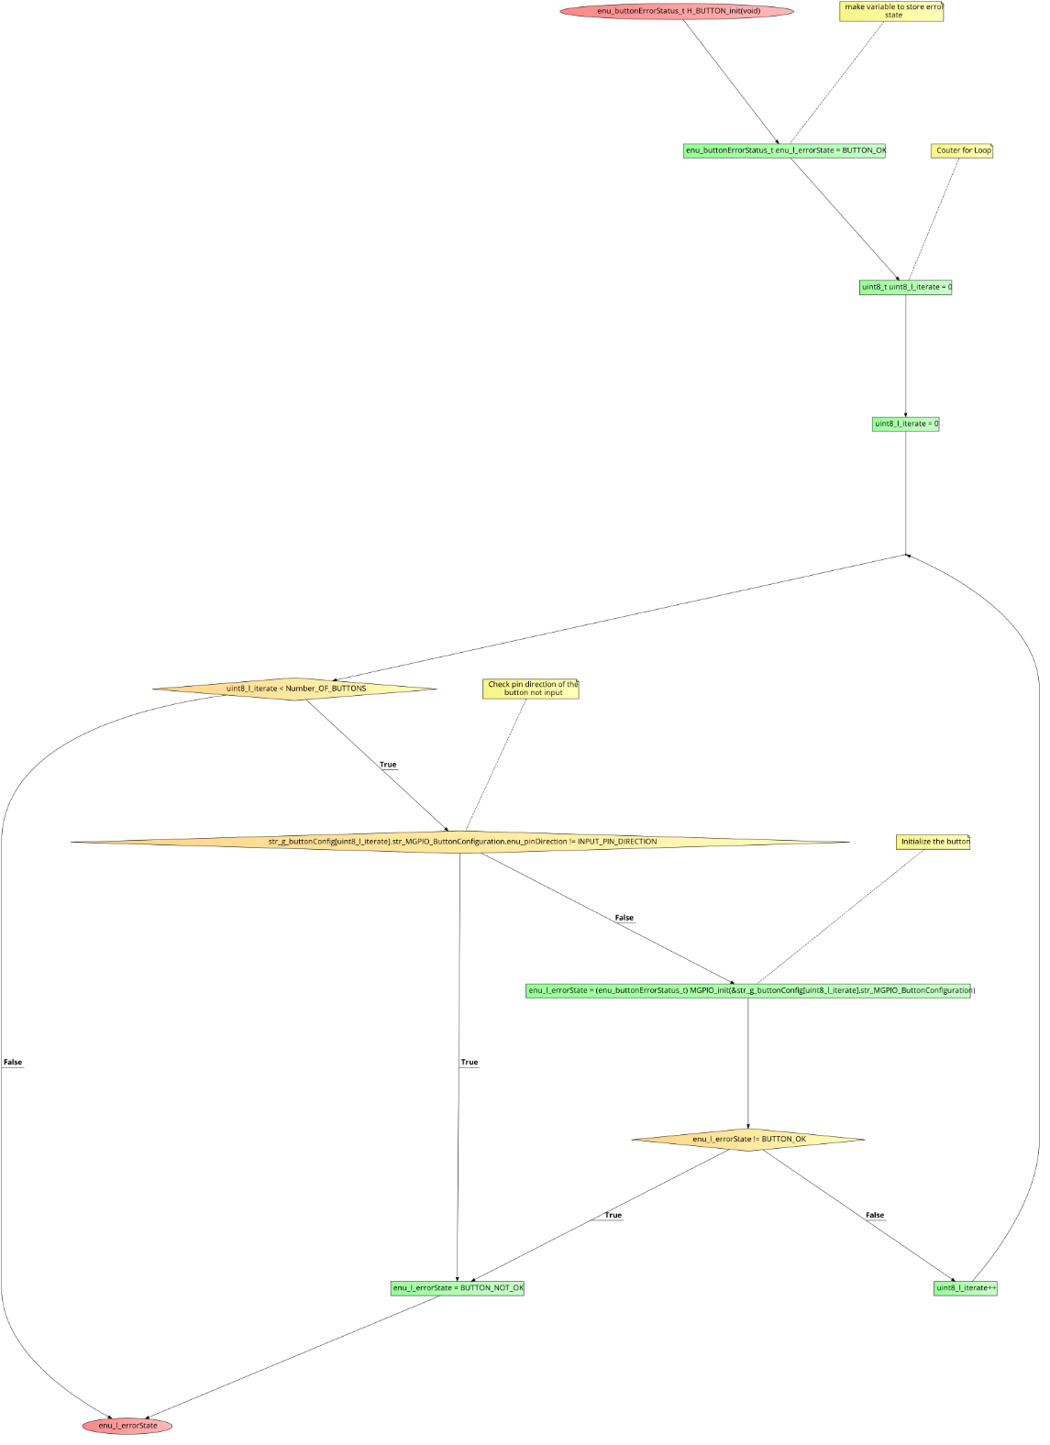

enu_buttonErrorStatus_t H_BUTTON_read(enu_buttonNumber_t enu_a_button_Number , boolean *ptr_a_value)

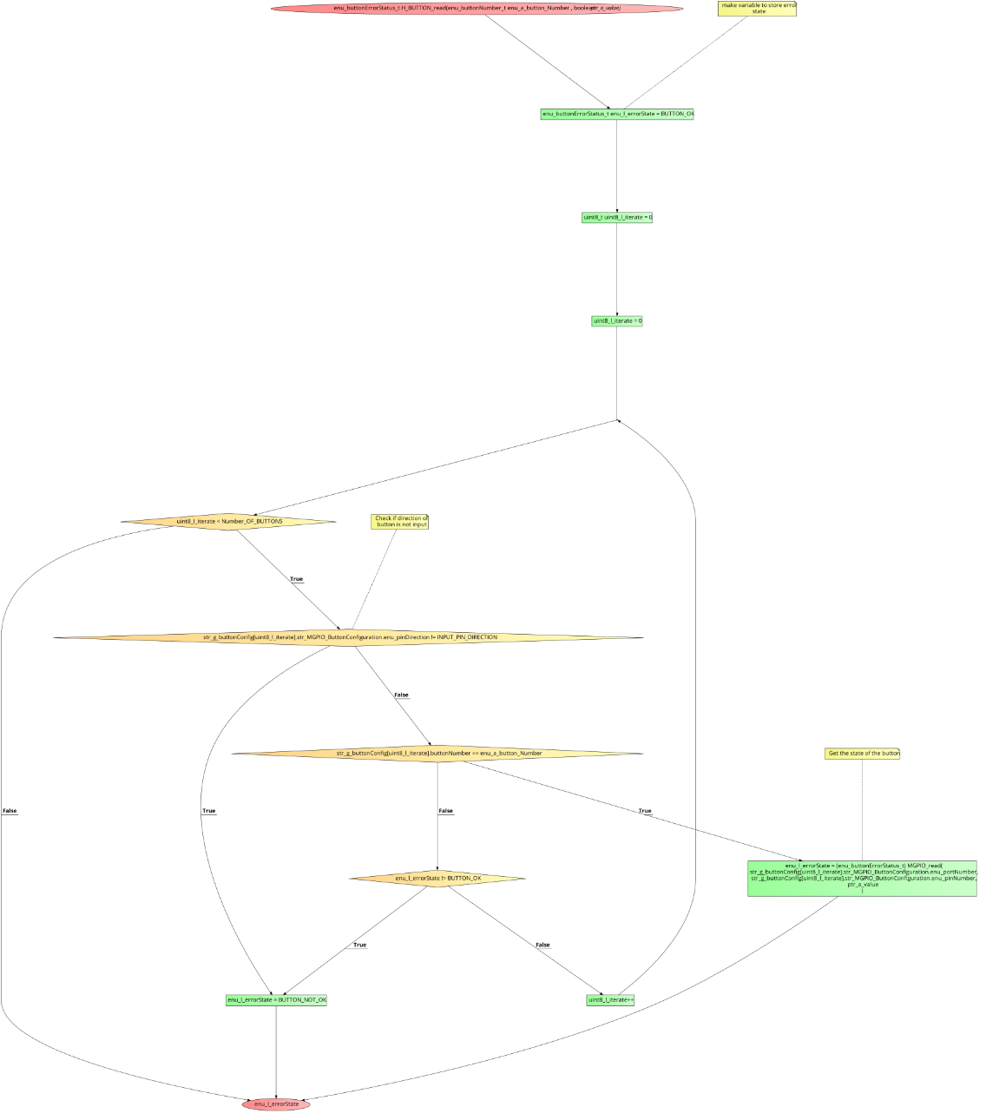

* APP

void appInit(void)

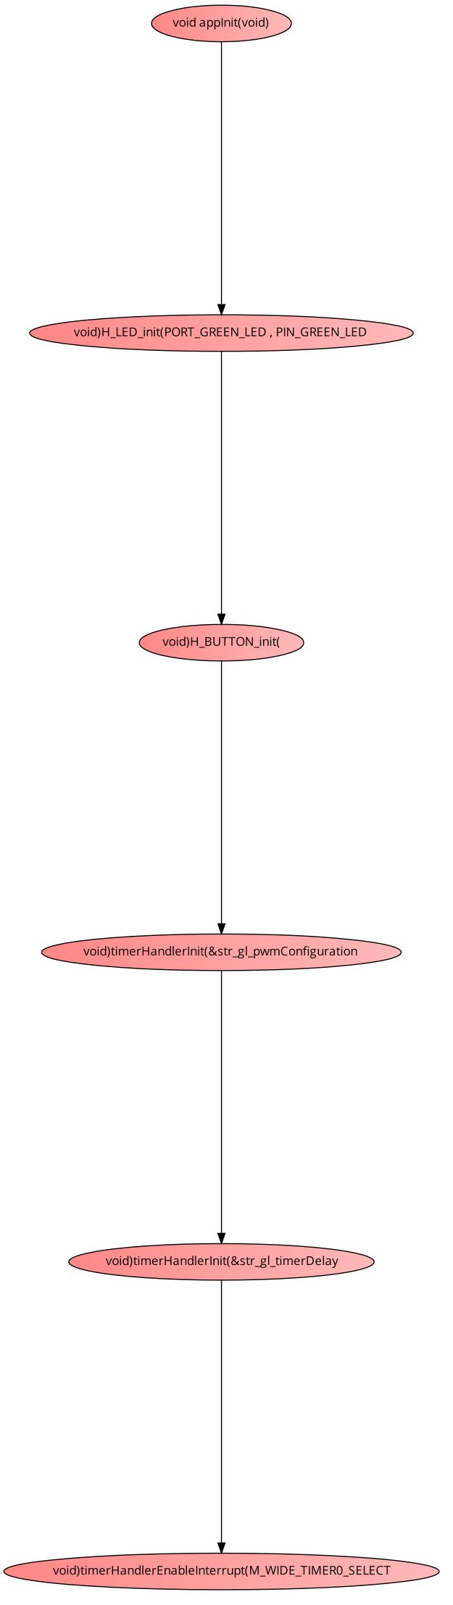

void appStart(void)

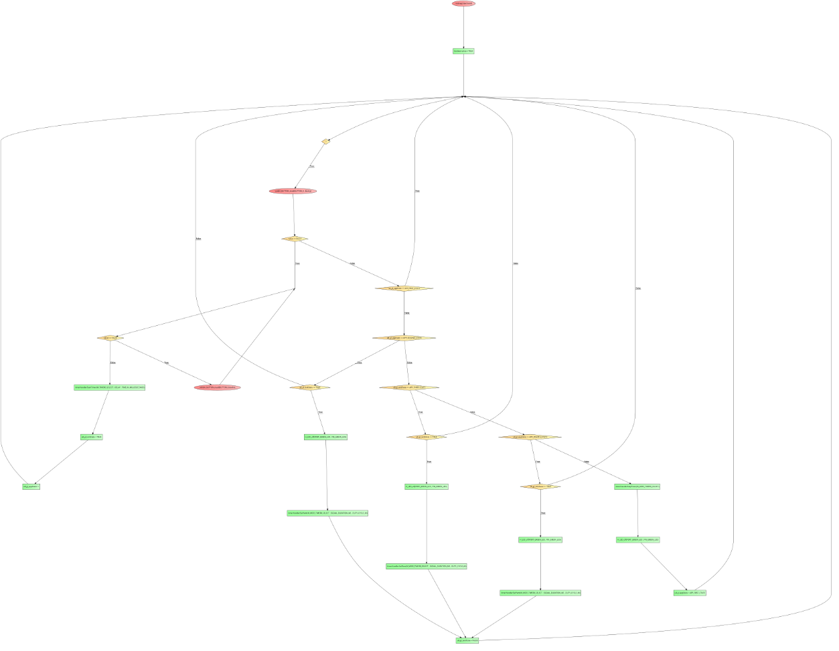

* Precompiling & Linking Configurations
* GPIO

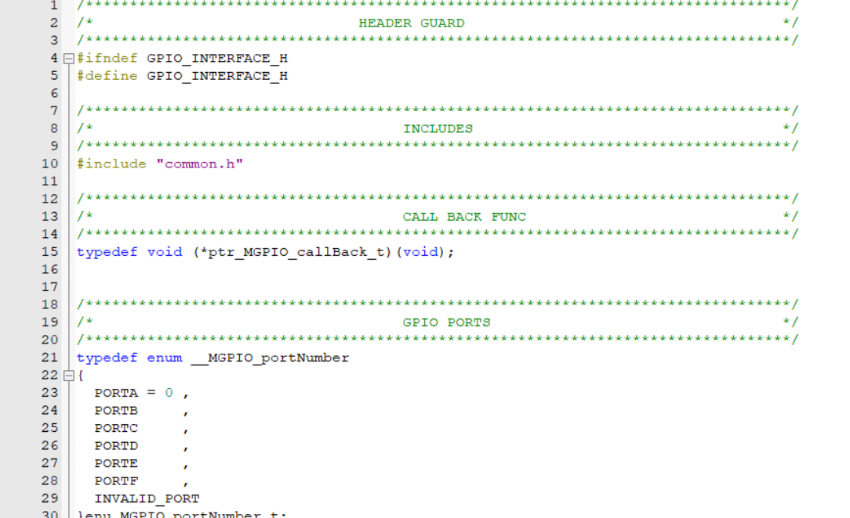

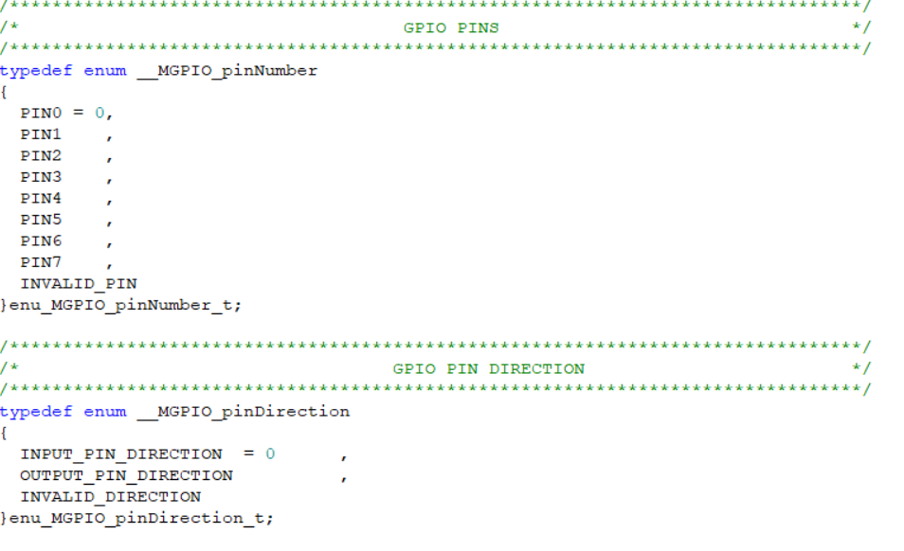

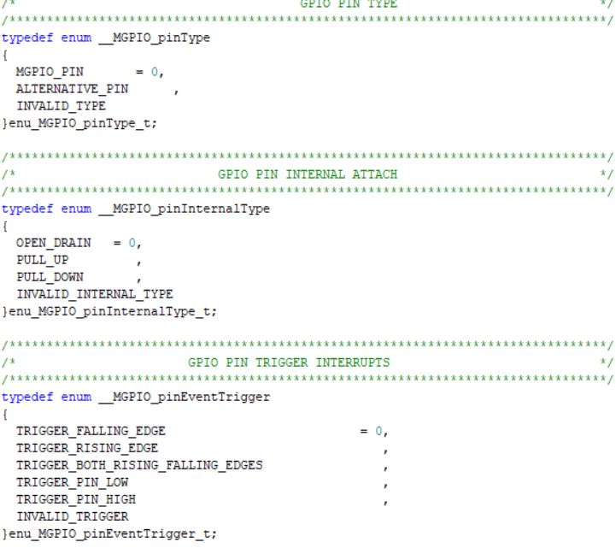

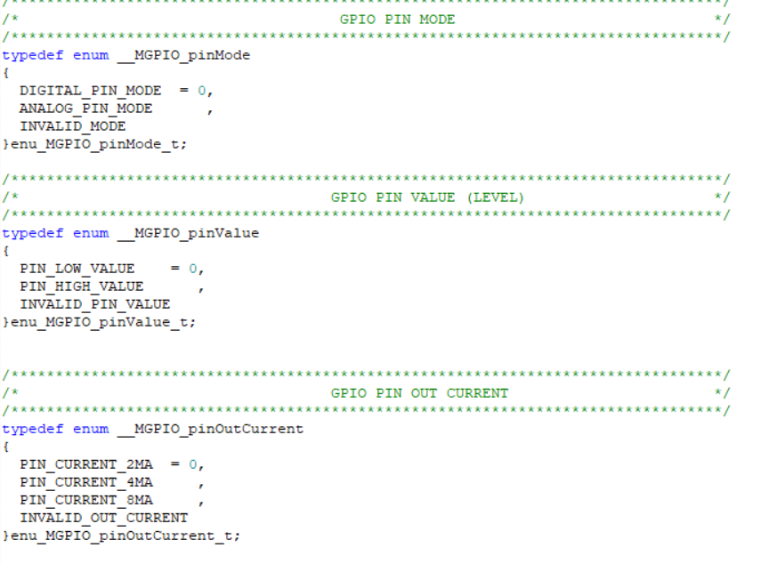

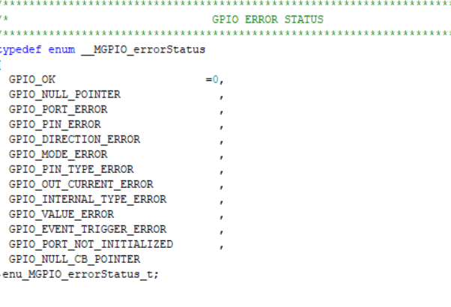

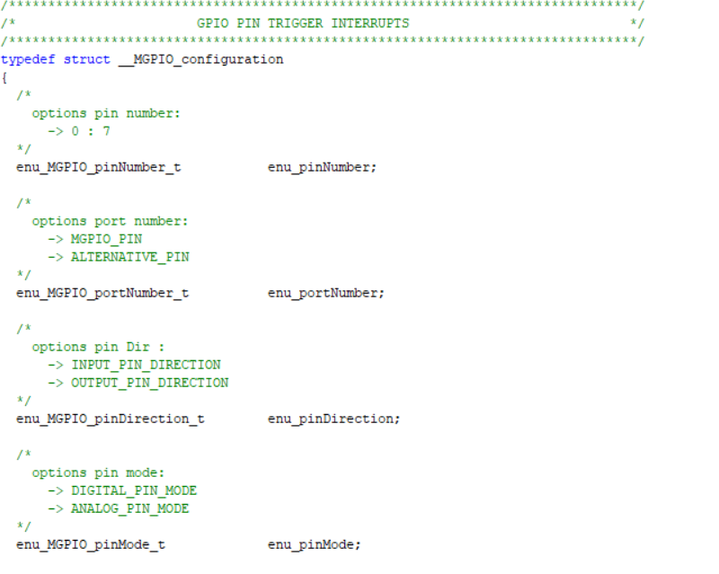

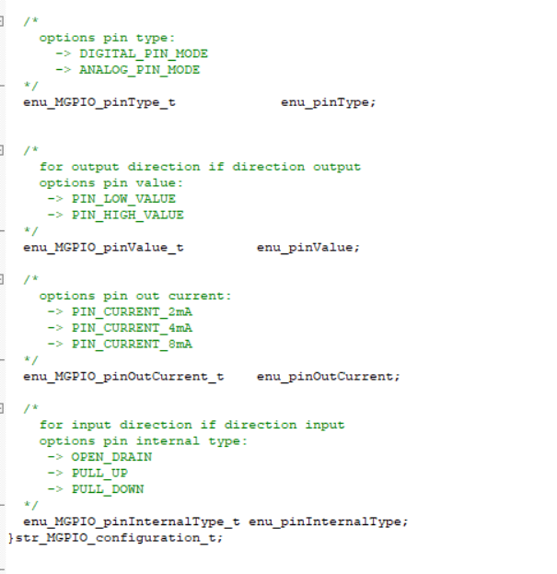

* 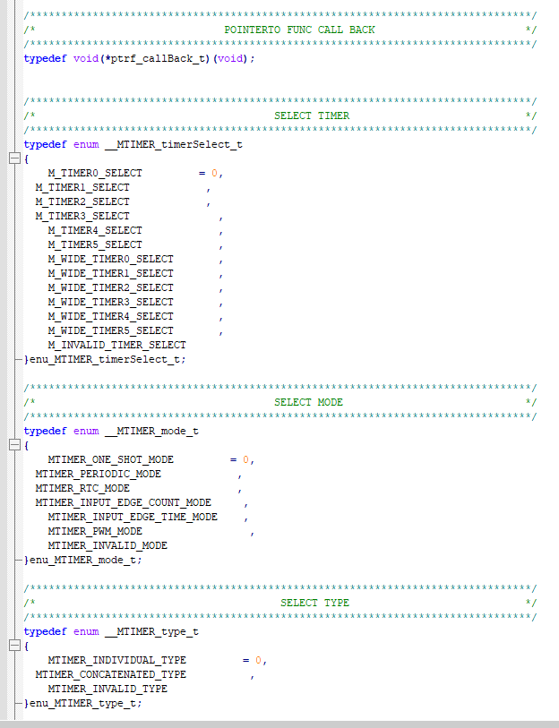GPT

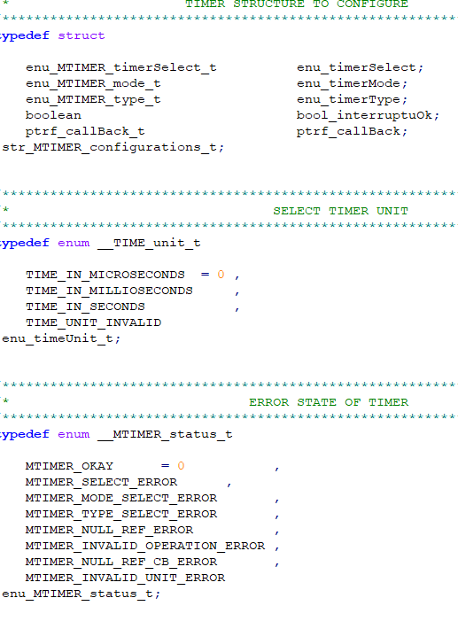

* LED

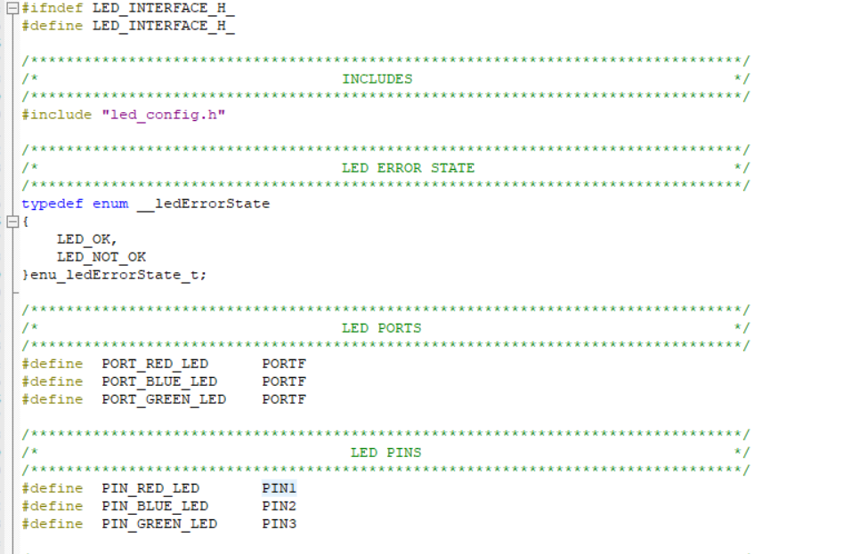

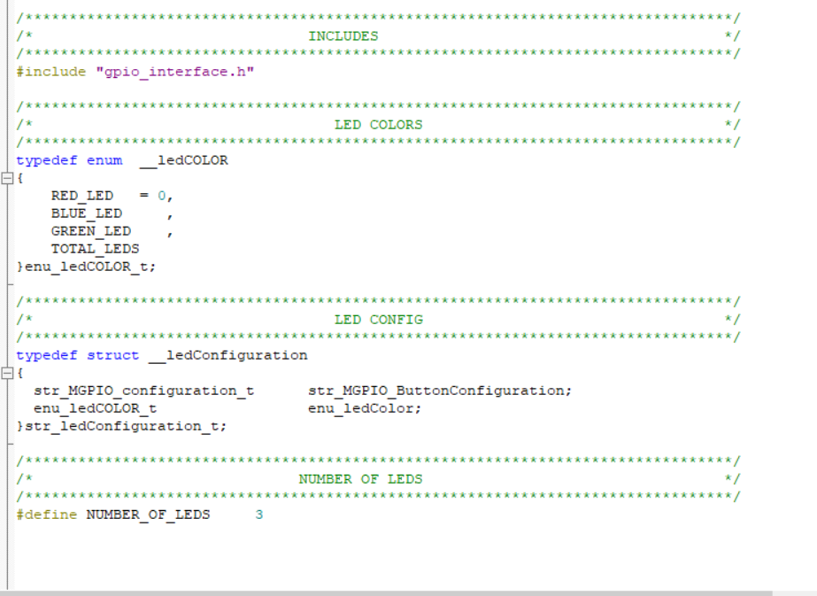

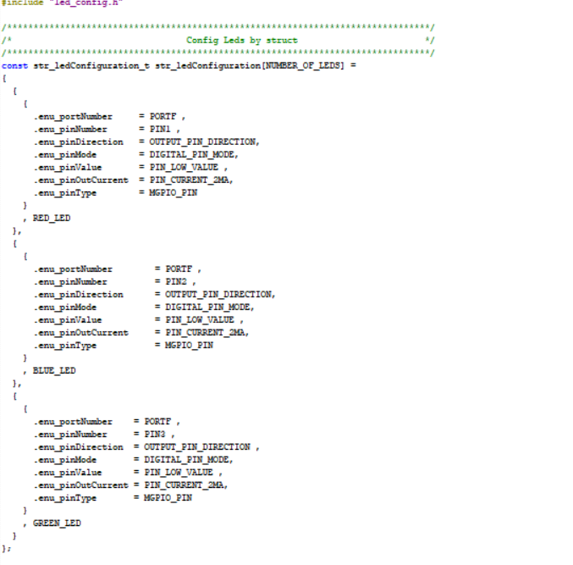

* BUTTON

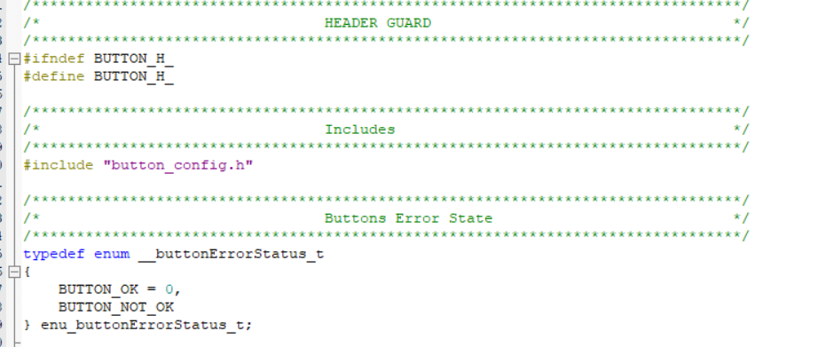

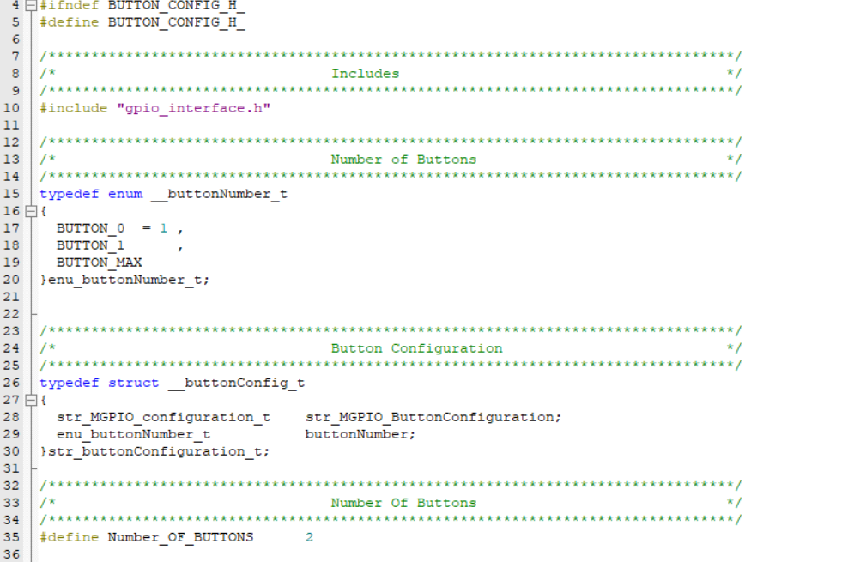

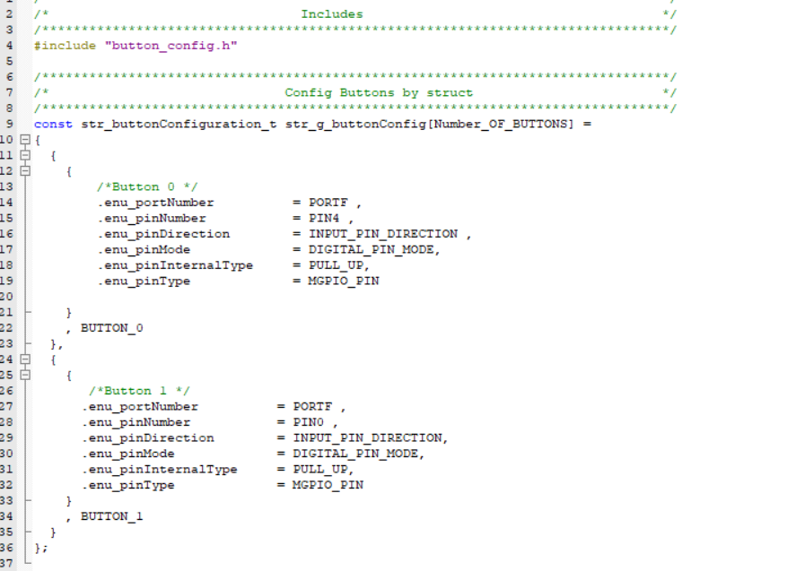

That is all requirements

Thanks